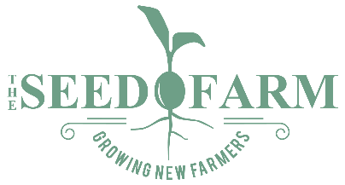

Farm Business Incubator
for the Establishment of Sustainable Farm-based Businesses

The Seed Farm’s Farm Business Incubator provides new farmers with access to land, infrastructure, equipment, and technical support during the first few years of farm business start-up. Incubator Farms are located alongside The Seed Farm’s farm, allowing staff to keep an eye on Incubator Farms and to be present for time-sensitive questions and consultations. Regular mentoring and technical assistance from Seed Farm staff provide new farmers with a safety net and continued dialogue on their practices.

Application Procedure

Applications are accepted on a rolling basis year-round. In some cases, prospective Incubator farmers may be advised to sign up for a business planning class or additional training. Formal application process detailed below.

Application process:
1. Submit application/farm plans
2. Applicants receive initial feedback from Seed Farm staff
3. Final farm plan review by Seed Farm Advisory Committee
4. Incubator Farmers notified of (A) acceptance into the Incubator, (B) issues in need of resolution before plans can be accepted, or (C) denial into the Incubator. In the case of (B), applicants may revise and resubmit their plan for a second review.
5. In the case of (A), a 1-year renewable lease will be issued.

After five years, Incubator farms enrolled in The Seed Farm Incubator program are required to relocate their farm off The Seed Farm site unless land is available for continued 1-year lease.

The Seed Farm is a program of
Second Harvest Food Bank of the Lehigh Valley and Northeast Pennsylvania
and Community Action Lehigh Valley

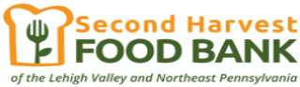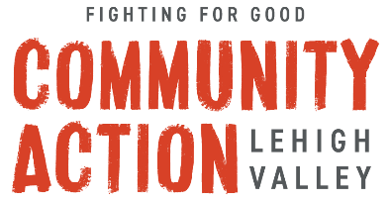

Application Requirements
All Incubator applicants must complete a Farm Business Plan as outlined below. Applications may be emailed to Katy Hunter, Program Administrator, at KHunter@CACLV.org.

Applications must include the following:

⬜ Cover Letter  ⬜ Cover Page  ⬜ Executive Summary  ⬜ Personal Business Concept  ⬜ Description of how the business is organized  ⬜ Marketing Plan  ⬜ Financial Plan  ⬜ Production Plan  ⬜ Risk Management Plan  ⬜ Appendices:  ⬜ Resume(s)  ⬜ Marketing materials  ⬜ Other documents that may be helpful in providing  evidence of the robustness of your plan and your  abilities. | Upon acceptance to the program Incubator farmers will be expected to supply the following:  ⬜ Copy of Business Registration  ⬜ Copy of IRS EIN Confirmation Letter  ⬜ Copy of current liability insurance for minimum of  $1,000,000.  ⬜ Completed production plan for all crops/products  Please include a cover letter that describes your interest in The Seed Farm Agricultural Incubator program and why you think that you are a good candidate to participate in this program.

An application guide/template is available upon request. Please include a cover letter that describes your interest in The Seed Farm Agricultural Incubator program and why you think that you are a good candidate to participate in this program.

